Landing Page

Thrash metal generally features fast tempos, low-register, complex guitar riffs, high-register guitar solos and double bass drumming. The rhythm guitar parts are played with heavy distortion and often palm muted to create a tighter and more precise sound. Vocally, thrash metal can employ anything from melodic singing to shouted vocals. Most guitar solos are played at high speed and technically demanding, as they are usually characterized by shredding, and use advanced techniques such as sweep picking, legato phrasing, alternate picking, tremolo picking, string skipping, and two-hand tapping.

The sound of thrash metal was shaped by a group of guitar players who would quite literally build a genre from the ground up. Four bands led the way, each with a duo of guitarists who have since gone on to legendary standing

Dubbed the “Big 4”, the founders of thrash metal are Metallica, Slayer, Megadeth, and Anthrax. This humble homage is dedicated to three of the four, and I’m replacing Anthrax with Pantera. Nothing against Anthrax. They’re a great band deserving much credit, but Pantera brought a new level to the genre.

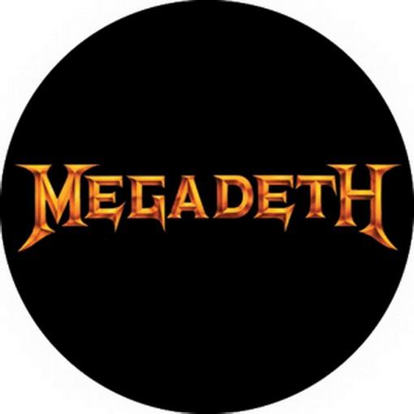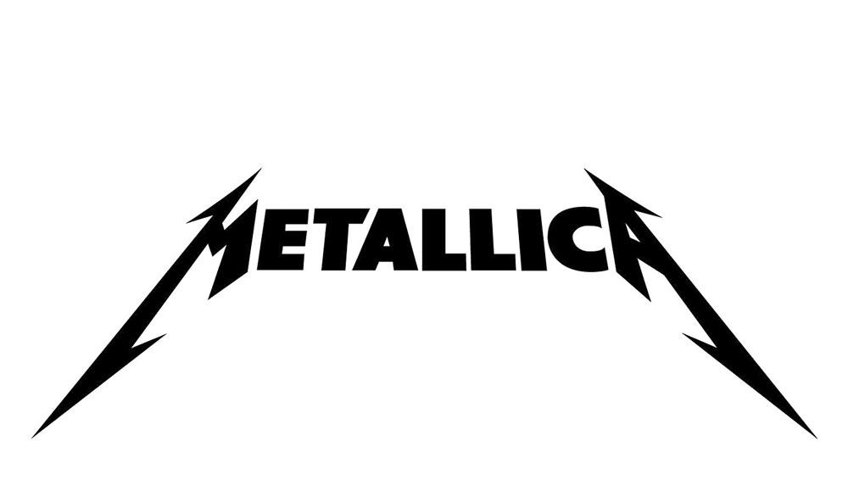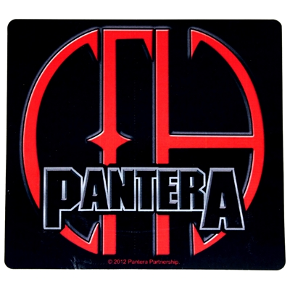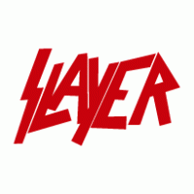

Metallica Page

Metallica is an American heavy metal band. The band was formed in 1981 in Los Angeles by vocalist/guitarist James Hetfield and drummer Lars Ulrich, and has been based in San Francisco for most of its career. The band's fast tempos, instrumentals and aggressive musicianship made them one of the founding "big four" bands of thrash metal..Metallica's current lineup comprises founding members and primary songwriters Hetfield and Ulrich, longtime lead guitarist Kirk Hammett and bassist Robert Trujillo. Guitarist Dave Mustaine (who went on to form Megadeth after being fired from the band) and bassists Ron McGovney, Cliff Burton (who died in a bus accident in Sweden in 1986) and Jason Newsted are former members of the band.

Metallica has released ten studio albums, four live albums, a cover album, five extended plays, 37 singles and 39 music videos. The band has won nine Grammy Awards from 23 nominations, and its last six studio albums (beginning with Metallica) have consecutively debuted at number one on the Billboard 200. Metallica ranks as one of the most commercially successful bands of all time, having sold over 125 million albums worldwide as of 2018. Metallica has been listed as one of the greatest artists of all time by magazines such as Rolling Stone, which ranked them at no. 61 on its 100 Greatest Artists of All Time list. As of 2017, Metallica is the third best-selling music artist since Nielsen SoundScan began tracking sales in 1991, selling a total of 58 million albums in the United States.

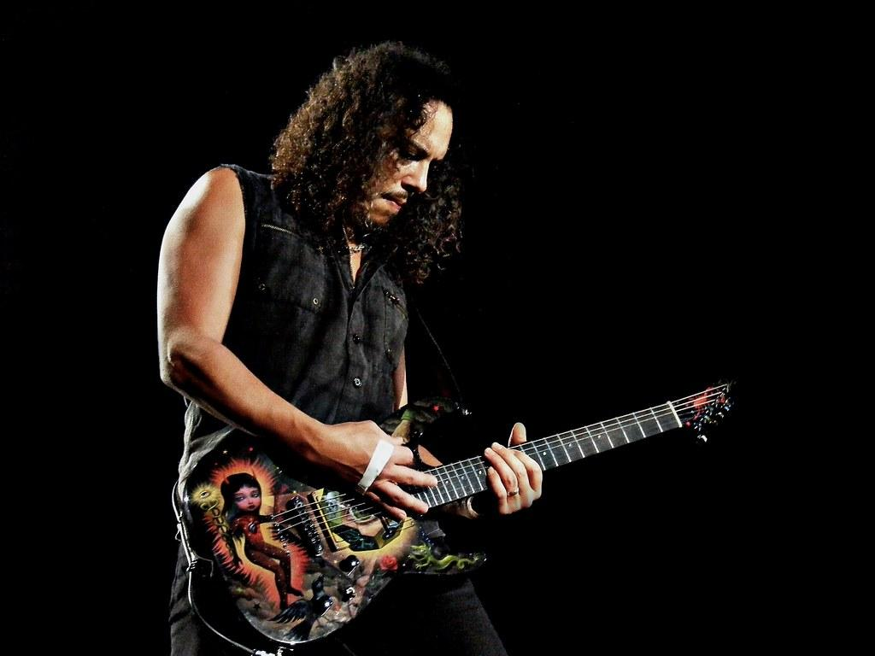

Megadeth Page

When Dave Mustaine got booted from Metallica he returned to California with a chip on his shoulder. Down but far from out, Mustaine put together a new band he’d name Megadeth, and they would quickly rise to prominence as a legitimate challenger for Metallica’s thrash metal throne.

Megadeth is the most progressive and most cerebral band of the Big Four. Even though they’ve endured lineup changes through the years, Mustaine has remained the constant, and his vision for the band has never wavered. Their music features complex arrangements and fast rhythm sections, and lyrical themes of death, war, politics, personal relationships and religion.

Megadeth has sold 38 million records worldwide, earned platinum certification in the United States for six of its fifteen studio albums, and received twelve Grammy nominations. Megadeth won its first Grammy Award in 2017 for the song "Dystopia" in the Best Metal Performance category. The band's mascot, Vic Rattlehead, regularly appears on album artwork and live shows. The group has drawn controversy for its music and lyrics, including album bans and canceled concerts; MTV refused to play two of the band's music videos that the network considered to condone suicide.

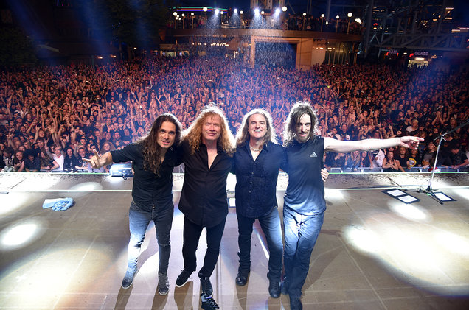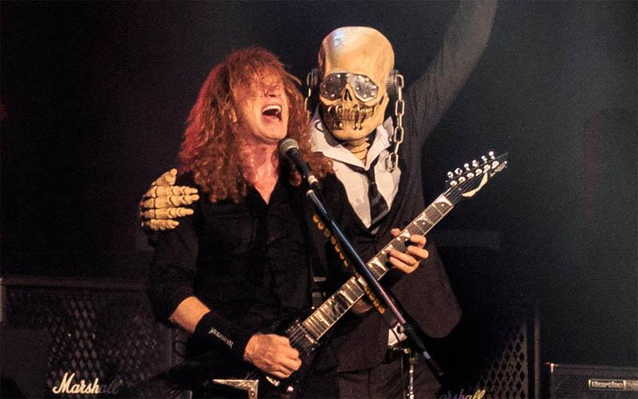

Slayer Page

Without a doubt Slayer is the heaviest, and possibly angriest, band of the Big Four from Huntington Park, California. The band was formed in 1981 by guitarists Kerry King and Jeff Hanneman, drummer Dave Lombardo, and bassist and vocalist Tom Araya. Slayer's final lineup comprised King, Araya, drummer Paul Bostaph and guitarist Gary Holt. Drummer Jon Dette was also a member of the band.

In the original lineup, King, Hanneman and Araya contributed to the band's lyrics, and all of the band's music was written by King and Hanneman. With lyrics and imagery that focus on the darker side of humanity they are seen by some metal historians as the definitive link between thrash and death metal. Album bans, delays, lawsuits and criticism from religious groups and factions of the general public have resulted. However, its music has been highly influential, often being cited by many bands as an influence musically, visually and lyrically; the band's third album, Reign in Blood (1986), was described as one of the heaviest and most influential thrash metal albums.

Slayer released twelve studio albums, two live albums, a box set, six music videos, two extended plays and a cover album. Four of the band's studio albums have received gold certification in the United States. The band has received five Grammy Award nominations, winning one in 2007 for the song "Eyes of the Insane" and one in 2008 for the song "Final Six", both of which were from the album Christ Illusion (2006). Between 1991 and 2013, the band sold five million albums in the United States. After more than three decades of recording and performing, Slayer announced in January 2018 that it would embark on its final world tour, which began that May and ended in November 2019, and the band subsequently disbanded.

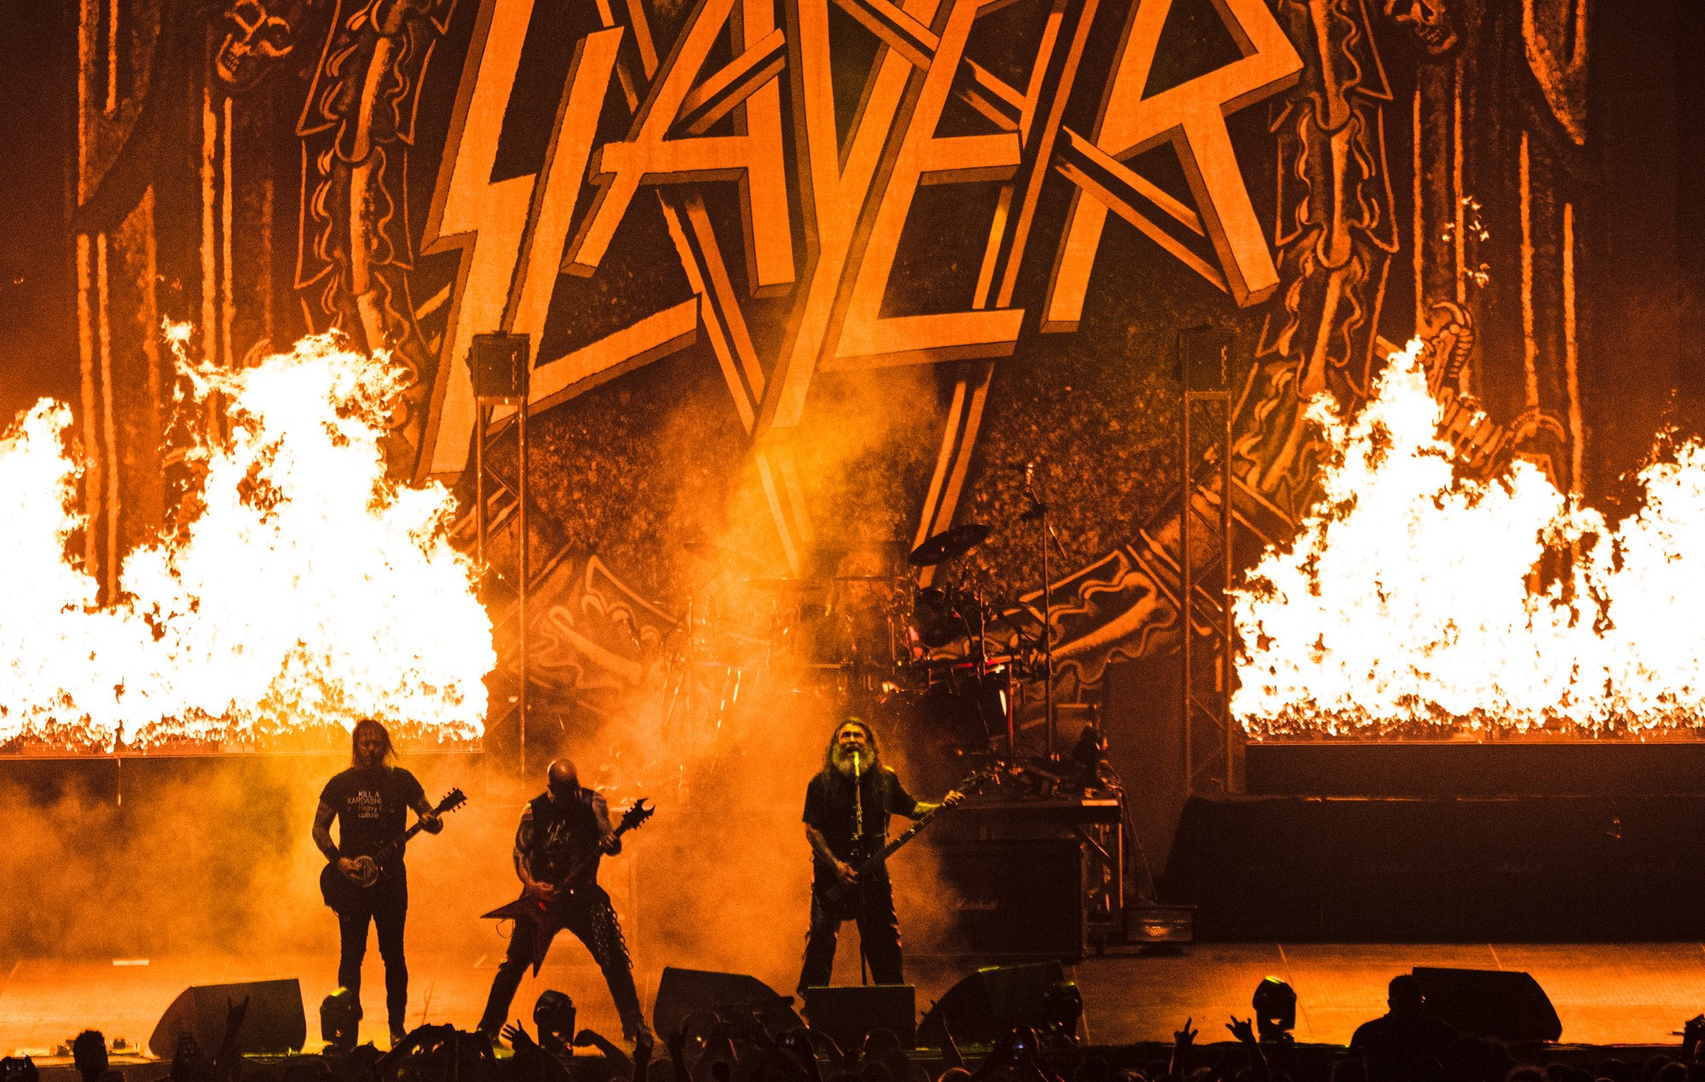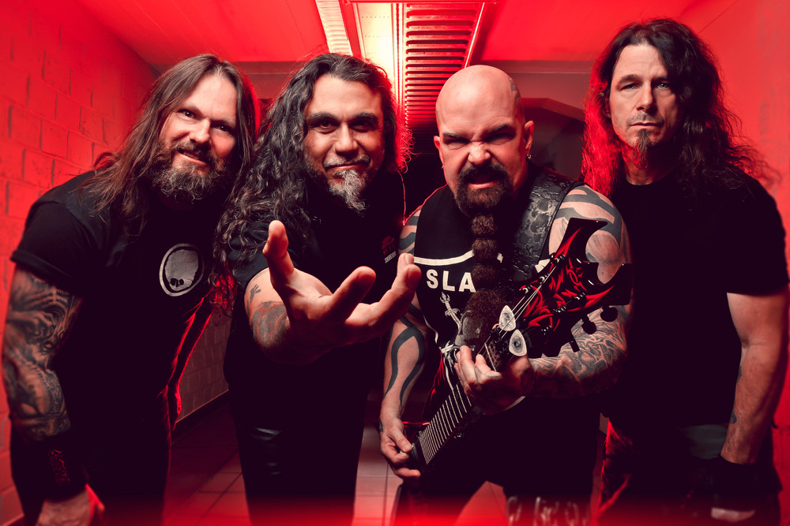

Pantera Page

Pantera. The band that started me down the path of heavy music. That fact may or may not have influenced the decision to boot Anthrax from this project.

Pantera was an American heavy metal band from Arlington, Texas formed in 1981. The group's best-known lineup consisted of the Abbott brothers—drummer Vinnie Paul and guitarist Dimebag Darrell—along with vocalist Phil Anselmo and bassist Rex Brown. In addition to their development and popularization of the groove metal subgenre, Pantera is credited (along with others such as Testament, Sepultura and Machine Head) for being part of the second wave of thrash metal scene from the late 1980s to early-to-mid 1990s.

Pantera released their seventh studio album, titled Far Beyond Driven, on March 22, 1994, which debuted at No. 1 in both United States and Australian album charts. The album's first single, "I'm Broken", earned the band's first Grammy nomination for "Best Metal Performance" in 1995. The album saw Pantera continue its groove metal approach, while taking an even more extreme direction with its musical style.

The Abbott brothers went on to form Damageplan, while Anselmo continued work on several side projects, including Down, which Brown joined as well. On December 8, 2004, Darrell was shot and killed on stage by a mentally unstable fan during a Damageplan concert in Columbus, Ohio. Vinnie Paul went on to form Hellyeah after his brother's death, and died of heart failure in 2018, leaving Brown and Anselmo as the only surviving members of the band's best-known lineup.

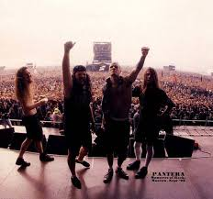 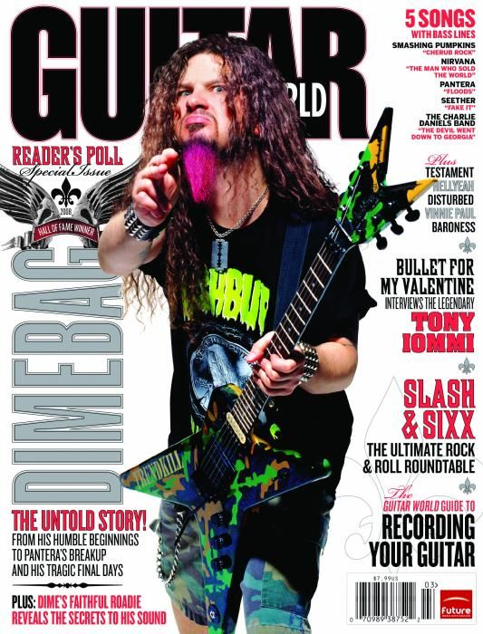

Sources:

<https://en.wikipedia.org/wiki/Pantera>

<https://en.wikipedia.org/wiki/Slayer>

<https://en.wikipedia.org/wiki/Megadeth>

<https://en.wikipedia.org/wiki/Metallica>

<https://en.wikipedia.org/wiki/Thrash_metal>

<https://spinditty.com/genres/Big-Four-Thrash-Metal-Bands-Guitar-Players>